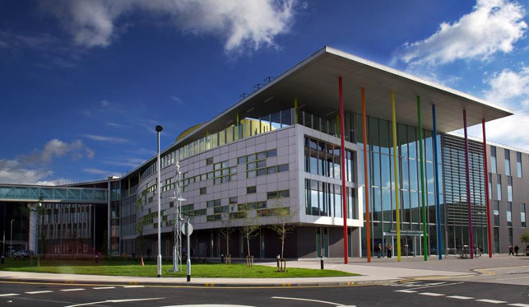
ESPU Masterclass: Off-Label Treatment of Bladder dysfunction

2nd June 2017
Royal Manchester Children’s Hospital, Manchester, UK

Masterclass is a concept introduced by the Educational Committee of the European Society for Paediatric Urology (EC-ESPU). The aim of such a meeting is to thoroughly discuss one chosen topic in a small group with specialists. Only a limited number of participants can be accepted. It is our privilege to invite you on behalf of the EC-ESPU and Department of Urology, Royal Manchester Children’s Hospital to participate in this Masterclass designed for clinicians who look after children with non-neurogenic day and night time wetting.
Objectives:
- To enhance understanding of non-neurogenic bladder disorders leading to day and night time wetting
- To gain insight into off-label treatment of difficult to treat overactive bladder, giggle incontinence, nocturnal enuresis and stress incontinence
- To share knowledge on efficacy, side effect profile of off-label medication
Audience: Paediatric Urologists and other professionals dealing with bladder dysfunction
Registration fee: £75 (number of participants restricted to 40)
Course Directors:
Anju Goyal / Rafal Chrzan
For more information visit:
http://kidneysforlife.org/news-events/conferences/
Link for registration:
https://espumasterclass.eventbrite.co.uk

Awarded 6 CPD points by the RCSEd

